Tasks

**Course**: Artificial Intelligence

(Machine Learning & Deep Learning)

Name: Abbas Shafi

Father Name: Dr Muhammad Shafi

Week: 01

Submitted to: Sir Syed Nazir Afridi



National Vocational & Technical Training Commission

National Center For Big Data & Cloud Computing

University of Engineering & Technology

Peshawar

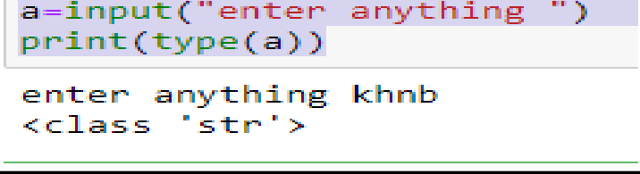

## Python Programming

**Introduction:**

Python programming is general purpose object oriented dynamic programming language used mainly in AI, ML, DL and data science. This language is known for their easiness and high level language. Contain large number of libraries through which programmer can easily handle tasks.

## Tool used:

* Jupyter Notebook
* Annaconda

**Task 1**: Write python program to add two number

**Code:** a=10 b=20

print(a+b)

## Output:

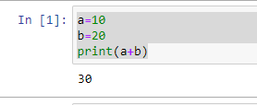

**Task 2:**Check the type of variable assign through input function.

### Code:

a=input("enter anything ") print(type(a))

**Task 3:** Use comparison operator to find whether a variable ‘a’ is greater then variable ‘b’ or not. a= 34 , b=80

## Code:

**a=34 b=80**

## print(a>b) Output:

**Task 4:**Write python program to find the remainder when number is divided by 2

## Code:

**a=4%2**

## print(a) Output:

**Task 5:** Write python program to find average of two number enter by user.

## Code:

num1=int(input("enetre num1 ")) num2=int(input("enter num2 ")) average=(num1+num2)/2 print("Average =",average)

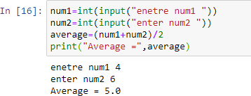

**Task 6:** Write python program to find square of a number enter by user.

## Code:

a=int(input("taking number ")) print(a**2)

**Output:**

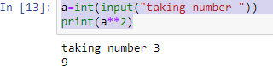

# LAB NO. 2

**Task 7**: Write python program to display name entered by user followed by good afternoon using input function.

## Code:

name=input("name ") print("Good afternoon ",name)

## Output:

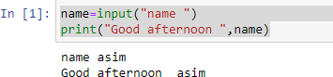

**Task 8:** Write a program to fill in letter template given bellow with name and date Letter=”Dear </name/>, you are selected </date/>

### Code:

name=input("enter name") date=input("date")

letter="Dear student you are selected come for interview on date" letter=letter.replace("student",name) letter=letter.replace("date",date)

print(letter)

## Output:

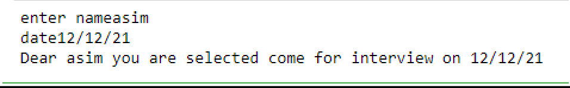

**Task 9:** Write a program to detect double spaces in string St=”Once upon a time”

## Code:

**str="once upon a time" str=str.find(" ") print(str)**

## Output:

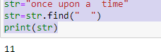

**Task 10:**Replace double space with single space in task3

## Code:

**str="once upon a time" str=str.replace(" "," ") print(str)**

## Output:

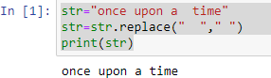

**Task 11:** Write a program to format following letter by using escape sequence character St=”Dear member This python course is nice thanks!.”

## Code:

**str="Dear Member,\n\tThis python course is mine Thanks!" print(str)**

## Output:

